Line Following Robot

# Project Name

Line Following Robot with Two Motors and Two IR Sensors

# Project Related Description

A typical line follower robot has two sets of motors, left motor and right motor. Both motors rotate based on the signals received from the left and right sensors, respectively. The robot performs 4 sets of motions: moving forward, turning left, turning right, and com- ing to a halt.

## Moving Forward

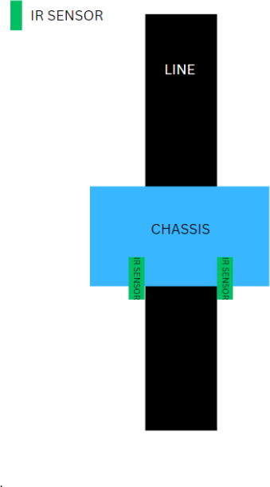When both sensors are on a white surface and the line is between the two sensors, the robot should move for- ward. Both motors rotate to move the robot forward (motors rotate in the opposite direction due to place- ment, but we’ll call it forward rotation for simplicity).

## Turning Left

When the left sensor is on the dark line and the right sensor is on the white part, the left sensor detects the black line and signals the microcontroller. The robot should turn left: the left motor rotates backward, and the right motor rotates forward, turning the robot left.

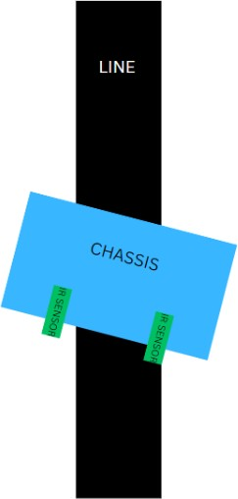

## Turning Right

When only the right sensor detects the line, the robot should turn right. The left motor rotates forward and the right motor rotates backward, turning the robot right.

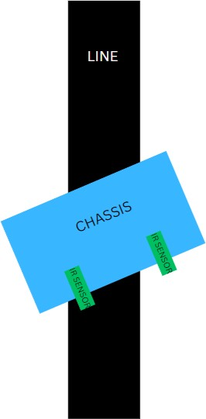

## Stopping

When both sensors detect the black line simultane- ously, the microcontroller considers this a halt con- dition. Both motors stop, causing the robot to stop moving.

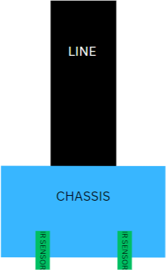

# Real-World Use Cases

Line-following robots have a variety of practical ap- plications in the real world. Some examples include:

* **Automated Guided Vehicles (AGVs)**: In warehouses and manufacturing plants, line-

following robots are used as AGVs to trans- port goods along predefined paths, increasing ef- ficiency and reducing human labor.

* **Public Transport Systems**: Some public transport systems use line-following technology to guide autonomous vehicles along dedicated routes, ensuring precise navigation and safety.
* **Educational Purposes**: Line-following robots are popular in educational settings, providing a hands-on learning experience for students in robotics and programming.
* **Tour Guides in Museums**: Some museums employ line-following robots to guide visitors along specific routes, providing an interactive and informative experience.

# Components Used in this Project

* Iron Chassis
* 2 IR Sensors
* 2 Wheels
* 2 Motors
* 1 Arduino Uno
* 2 Rows of a Breadboard
* Jumper Wires
* 1 Motor Drive
* Soldering Kit
* 1 9V Battery

# Circuit Diagram Software (TinkerCAD)

[TinkerCAD Link](https://www.tinkercad.com/things/assRWekfldB-mighty-maimu-blorr/editel?sharecode=27SzfACfEoSZoy-H-GLxygqr3nvL7PrpeZVx79lg6do)

# Arduino Code

[Arduino Code Link](https://drive.google.com/file/d/1QhanjlCYkJNauD2Sn0matPrJTaMuux1d/view?usp=sharing)